Christmas Card and Calendar

Order Form 2025

Please fill out the form below to order a supply of Christmas Cards for your committee. There will be various opportunities to place orders through the show/event season, each order will be limited to £500 to ensure we can keep up with orders and any necessary reprints.
Order should be delivered to (we will deliver to the same contact each time you place an order):
Name
Address
Postcode
Email
Phone number

Card name and stock no. | Card photo | Quantity of packs (packs contain 10 cards apart from the bumper pack which contains 30)
Geese at the Farm  (10 cards per pack to be sold at £5 per pack) | 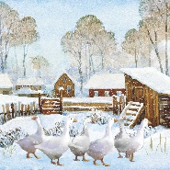
Bought Myself a New Hat  (10 cards per pack to be sold at £5 per pack) | 
Conducting the Choir  (10 cards per pack to be sold at £5 per pack) | 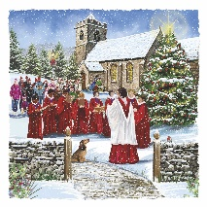
Woolly Blankets  (10 cards per pack to be sold at £6 per pack) | 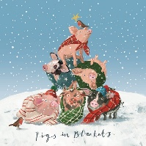
Gardeners Friends (blank inside)  (10 cards per pack to be sold at £6 per pack) | 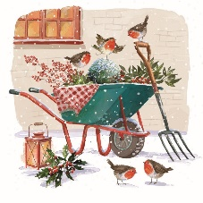
Watching the flock  (10 cards per pack to be sold at £6 per pack) | 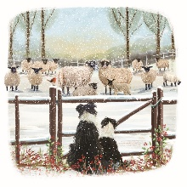
Watching the flock – BILINGUAL
(10 cards per pack to be sold at £6 per pack)
Bumper pack  (30 cards per pack to be sold at £10 per pack) | 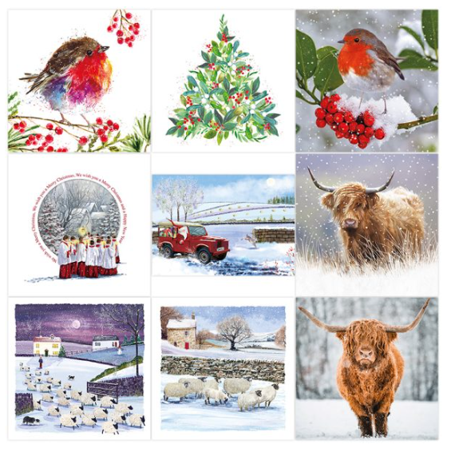

Please send your order to volunteering@rabi.org.uk and copy in you Regional Manager.

