Christmas Card and Calendar Order Form 2026
Please fill out the form below to order a supply of Christmas Cards for your committee. Please try to make as few orders as possibly as we are charged for delivery per order.
Order should be delivered to (we will deliver to the same contact each time you place an order):
Name
Address
Postcode
Email
Phone number

Card name and stock no. | Card photo | Quantity of packs (packs contain 10 cards)
Farmyard Friends  (10 cards per pack to be sold at £6 per pack) | 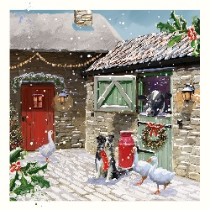
Snow on the Farm  (10 cards per pack to be sold at £6 per pack) | 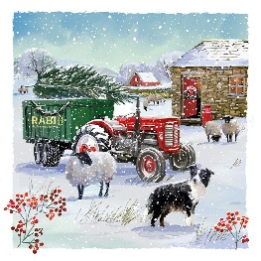
Together at Christmas  (10 cards per pack to be sold at £6 per pack) | 
By the Manger  (10 cards per pack to be sold at £6 per pack) | 
Robins in the Garden  (10 cards per pack to be sold at £6 per pack) | 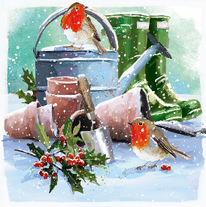
Woolly Scarf  (10 cards per pack to be sold at £6 per pack) | 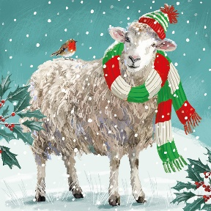
Woolly Scarf – BILINGUAL  (10 cards per pack to be sold at £6 per pack) | 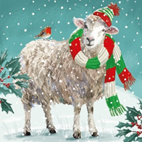
Wall Calendar 2027  (to be sold at £10 per calendar) | 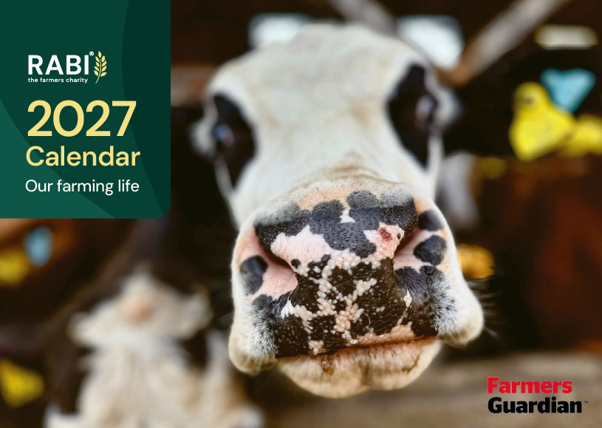
Desk Calendar 2027  (to be sold at £8 per calendar) | 

Please send your order to committees@rabi.org.uk.

